Team 1 Open Source Air Quality Monitoring

Week 18: May 8th 2022 - May 15th

Sponsor: Dr. [David Burnett](mailto:dburnett@pdx.edu)

Advisor: Dr. John Acken

Team Members: [Adam Dezay](mailto:adezay@pdx.edu), [Manuel Garcia](mailto:manga2@pdx.edu), [Brandon Hippe](mailto:bhippe@pdx.edu), Mercedes Newton

**Team Review:**

* Met with Dr. Acken and Dr Burnett in person to update team progress and outline PCB, enclosure, and mounting plans
* Finished PCB version 1, waiting on arrival
* Enclosure 3D Models being finalized, getting ready to print in EPL
* Figured out SmartMesh IP functionality, ran 3hr test during WEST Lab Group Meeting obtaining CO2 and PM data

**Individual Review**

Adam Dezay:

Updated wiki to include last week’s report as well as the home page for the Wiki. Received the enclosure files from mercedes and am looking to get started on printing it and making adjustments as we see fit to match any of our components using FreeCAD. Also got more of the manual/instructions complete to include any trouble we encountered.

Manuel Garcia:

Made several small changes to the original PCB schematic. Sourced and ordered components for PCB. Found footprints and designed KiCad model. Ordered PCB with express shipping. PCB should be in within the next week (Hopefully before friday). Finalized battery/ power management design and ordered those parts as well.

Brandon Hippe:

Figured out SmartMesh issues, fixed up main code and ran first tests. Starting to work on modifying last year’s python scripts to fit our use case.

Mercedes Newton:

Drafted several concept designs for final project enclosure. Got the go ahead on one model with several different configurations depending on included sensors. Designed in FreeCAD, the first edition of our enclosure to be made on the “HYDE” 3d printer in the EPL. Turned over to Manuel & Adam to get 3D printed this week. Adjusting and editing 3d models as changes are suggested and discrepancies found.

**Gantt Chart and Timeline Updates:**

Below is both the timeline of the projected project progress for spring term. Figure 1 represents the gantt chart for the term with expected completion dates beginning March 25th. All specific dates for the upcoming term are specified in the table below.

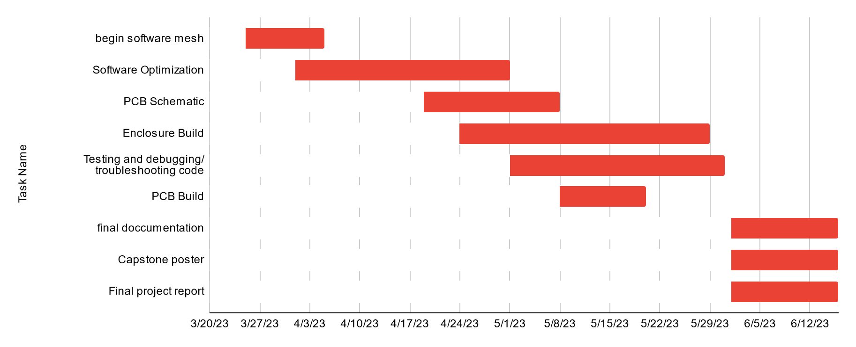

Figure One: Gantt chart for spring term (first task starts 3/25/2013)

| Task Name | Start date | End date |
| --- | --- | --- |
| Begin software mesh | 3/25/2023 | 4/5/2023 |
| Software Optimization | 4/1/2023 | 5/1/2023 |
| PCB Schematic | 4/19/2023 | 5/8/2023 |
| Enclosure Build | 4/24/2023 | 5/29/2023 |
| Testing and debugging/ troubleshooting code | 5/1/2023 | 5/31/2023 |
| PCB Build | 5/8/2023 | 5/20/2023 |
| final documentation | 6/1/2023 | 6/16/2023 |
| Capstone poster | 6/1/2023 | 6/16/2023 |
| Final project report | 6/1/2023 | 6/16/2023 |

Table One: Tasks for spring term with expected completion dates *completion dates subject to change*